Matthew Lai

CS 519 Project 1

1. Global Histogram Equalization

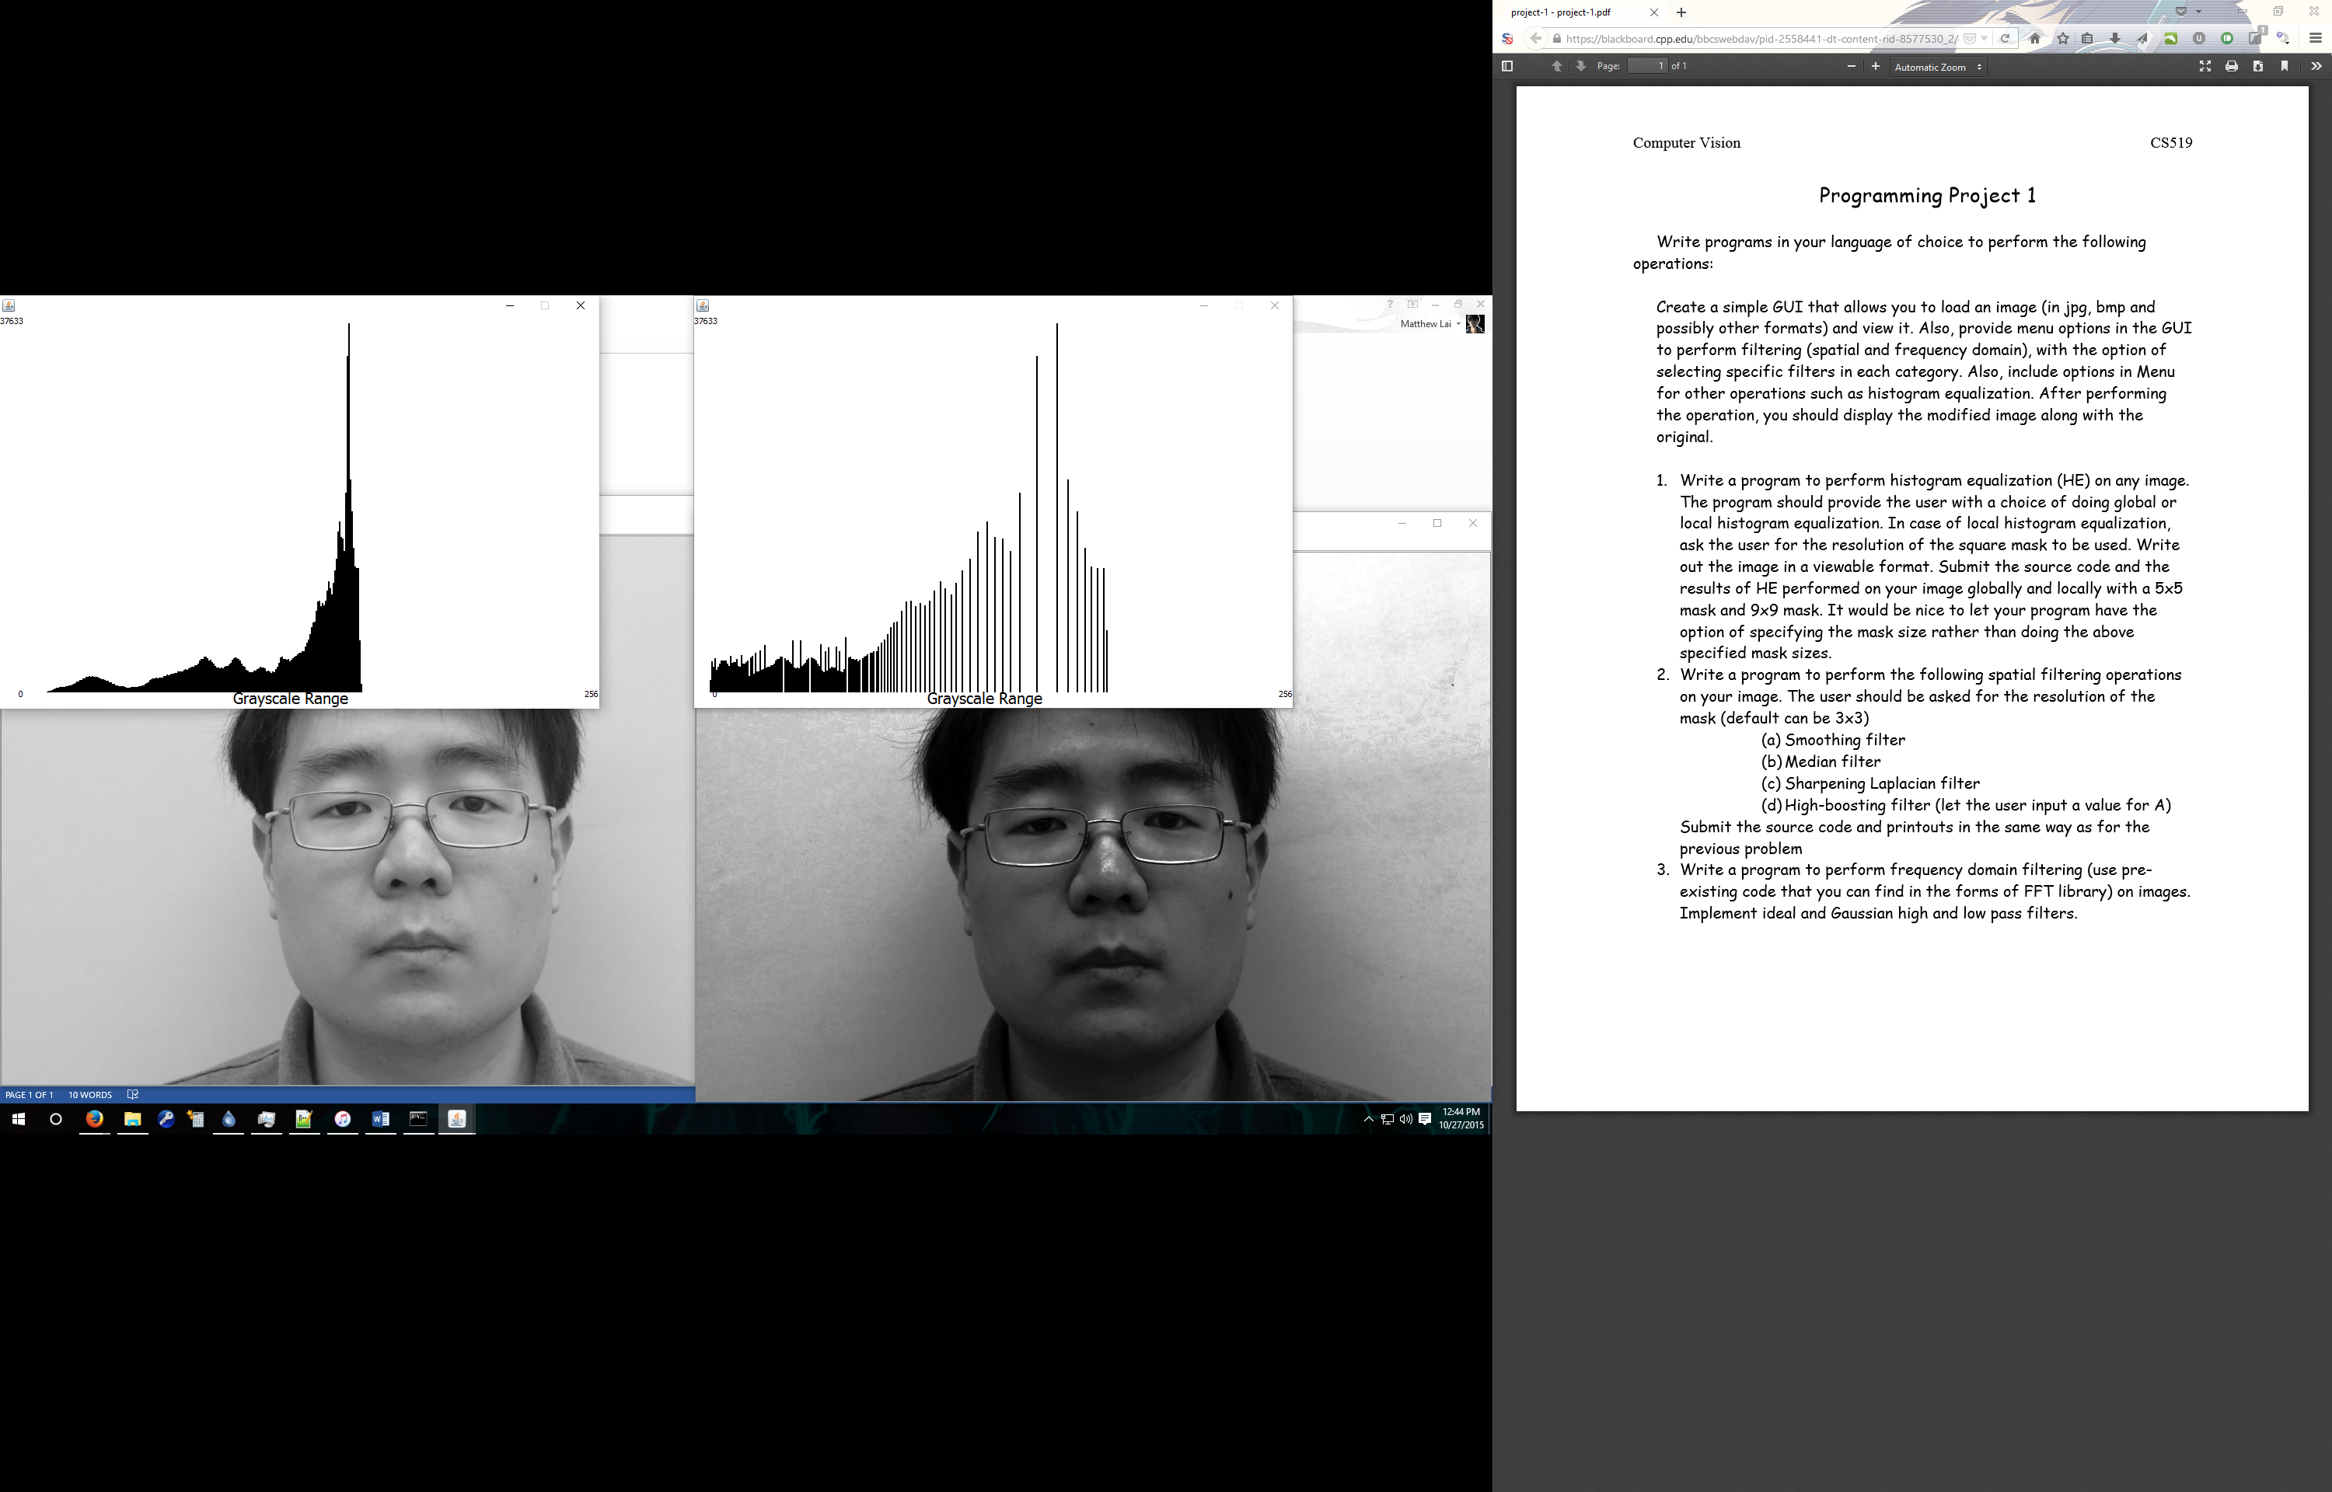

Local Histogram Equalization

5 x 5

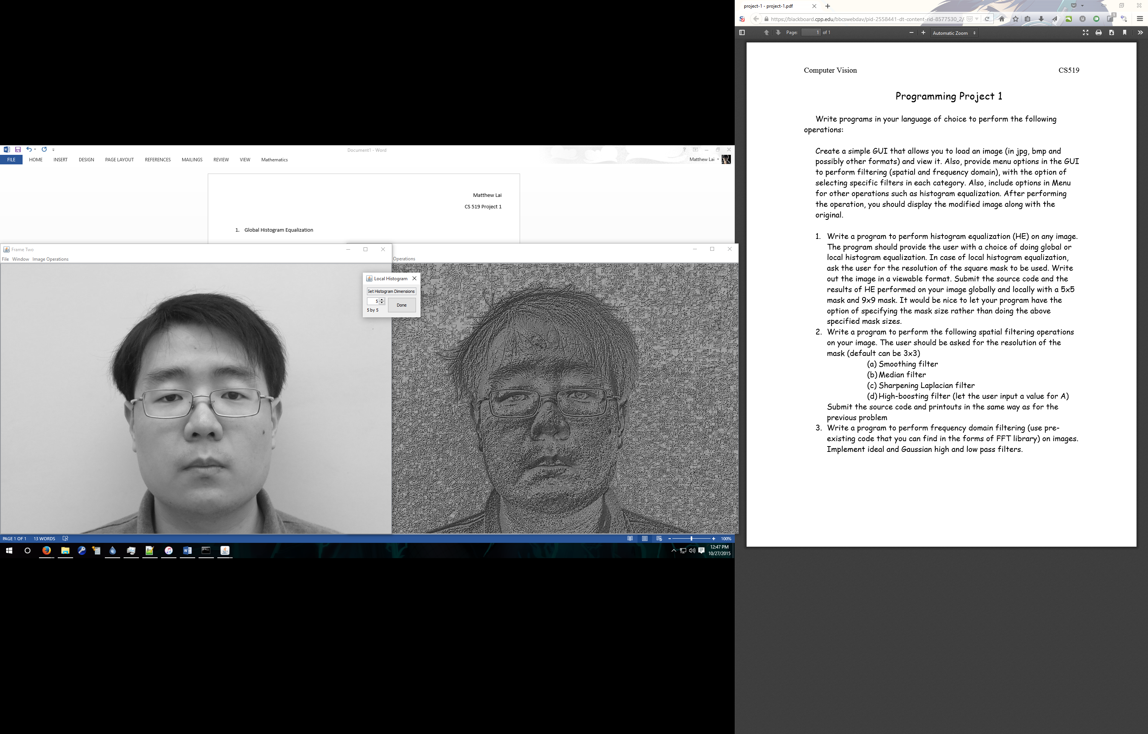

9 x 9

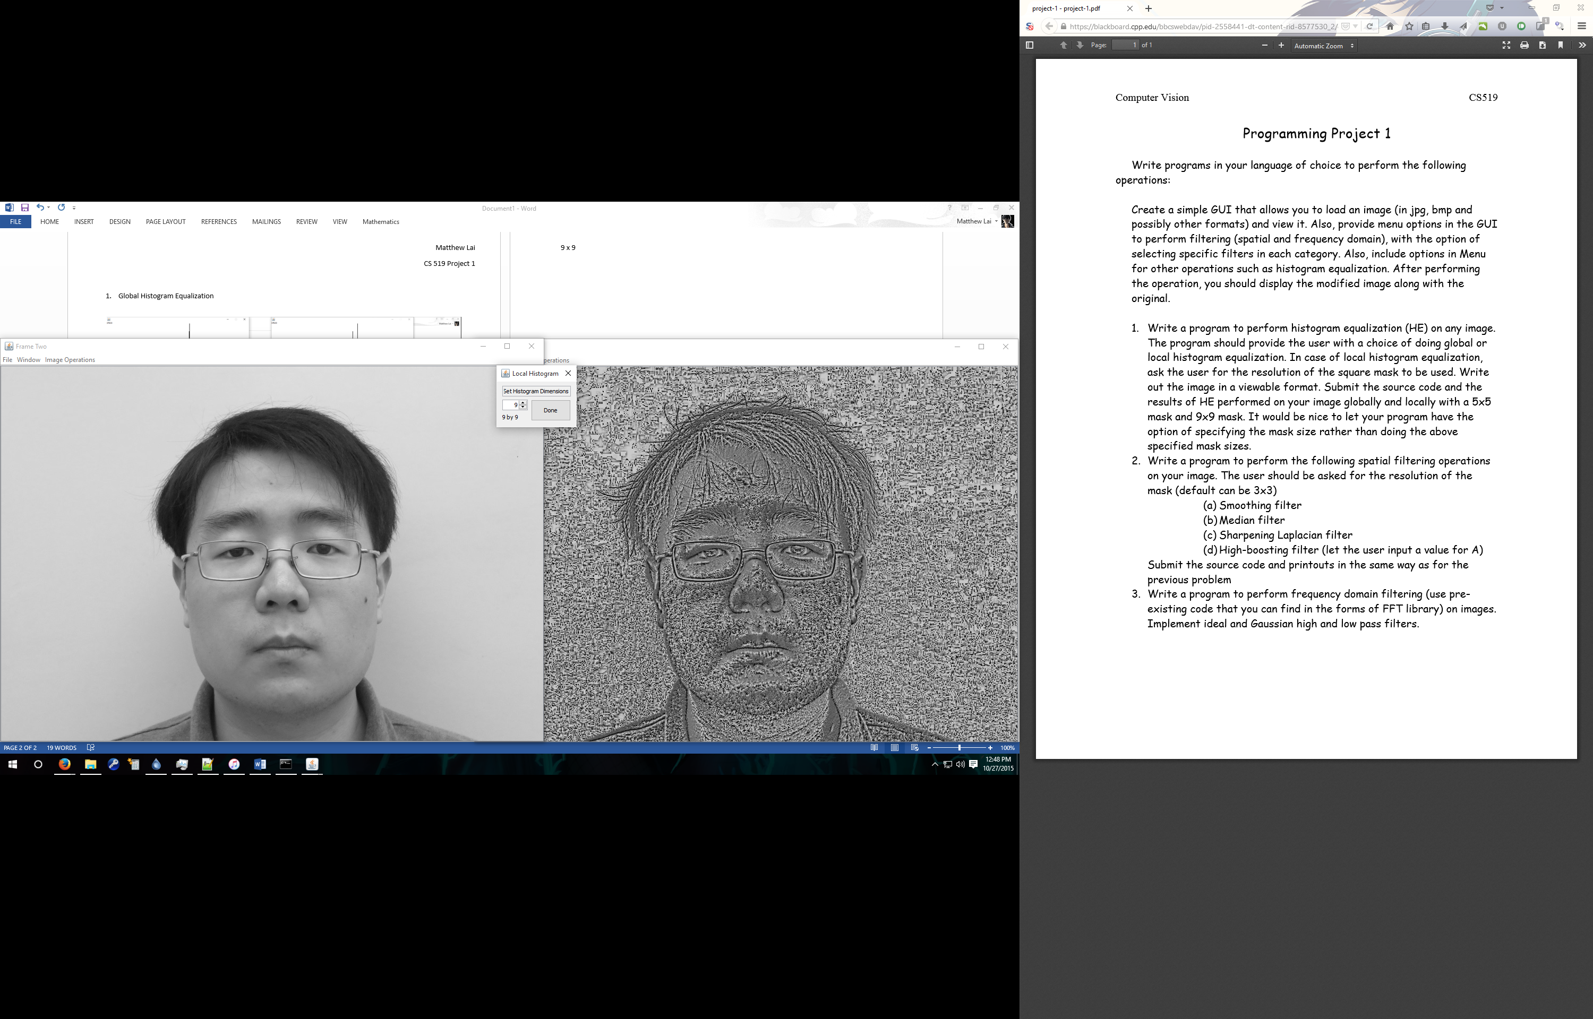

Source Code (Also Located in src/P1Filters/HistogramEqualization.java):

///////////////////////////////////////////////////////////////////////////////////////////////////////////////////////

// Equalizes the images using local histograms

///////////////////////////////////////////////////////////////////////////////////////////////////////////////////////

public int[][] equalizeLocal(int[][] original)

{

// GUI Elements

SpinnerGet spinn = new SpinnerGet();

spinn.setVisible(true);

int dim = spinn.getSpinnerValue();

spinn.dispose();

// New Image

int[][] newImage = new int[original.length][original[0].length];

int dimdim = dim*dim;

// Calculating Bit depth

int bitCount = HistogramGen.getBitCount(original);

for (int i = 0; i < newImage.length; i++)

for (int j = 0; j < newImage[i].length; j++)

{

// Calculating the local histogram

int[] hist = HistogramGen.generateLocalHist(original, i, j, dim, bitCount);

// Totalling the current histogram value with previous histogram entries

double total = 0;

int k = original[i][j];

while (k >= 0) total += ((double)hist[k--]);

// New pixel value based on the local histogram cluster

int value = (int)Math.round(total/dimdim * (hist.length));

// Writing the new pixel value to the array.

newImage[i][j] = value;

}

return newImage;

}

///////////////////////////////////////////////////////////////////////////////////////////////////////////////////////

// Equalizes the images using global histograms.

///////////////////////////////////////////////////////////////////////////////////////////////////////////////////////

public int[][] equalizeGlobal(int[][] original)

{

// New Image

int[][] newImage = new int[original.length][original[0].length];

int MN = original.length * original[0].length;

// Calculate the global Histogram

int[] histogram = HistogramGen.generateGlobalHist(original);

new HistogramChart(histogram).setVisible(true);

for (int i = 0; i < newImage.length; i++)

for (int j = 0; j < newImage[i].length; j++)

{

// Totalling the current histogram value with previous histogram entries

double total = 0;

int k = original[i][j];

while (k >= 0) total += ((double)histogram[k--]);

// New pixel value based on the local histogram cluster

int value = (int)Math.round(total/MN * (histogram.length - 1));

// Writing the new pixel value to the array.

newImage[i][j] = value;

}

// NORMALIZE HERE!!!

newImage = ImageProcessor.ImageUtilities.normalize(newImage, 8);

new HistogramChart(HistogramGen.generateGlobalHist(newImage)).setVisible(true);

return newImage;

}

@Override

public String getFilterName()

{

return "Historgram Equalization";

}

@Override

public String getFilterDecription()

{

return "Equalizes the image based on the image histogram.";

}

@Override

public String getFilterCategory()

{

return "Project 1";

}

public static int[] generateLocalHist(int[][] image, int x, int y, int dim, int bitCount)

{

int[] histogram = new int[bitCount];

for (int i = 0; i < histogram.length; i++)

{

histogram[i] = 0;

}

for (int i = -dim/2; i < dim/2; i++)

for (int j = -dim/2; j < dim/2; j++)

{

int currentX = x+i;

int currentY = y+j;

if (currentX < 0) currentX = 0;

if (currentY < 0) currentY = 0;

if (currentX >= image.length) currentX = image.length-1;

if (currentY >= image[0].length) currentY = image[0].length-1;

histogram[image[currentX][currentY]]++;

}

return histogram;

}

public static int[] generateGlobalHistogram(int[][]image)

{

int max = 0;

for (int i = 0; i < image.length; i++)

for (int j = 0; j < image[i].length; j++)

if (image[i][j] > max) max = image[i][j];

int histogramLength = (int)Math.pow(2, 0);

int c = 0;

while (histogramLength <= max) histogramLength = (int)Math.pow(2, ++c);

int[] histogram = new int[histogramLength];

for (int i = 0; i < image.length; i++)

for (int j = 0; j < image[i].length; j++)

histogram[image[i][j]]++;

return histogram;

}

1. Spatial Filtering
   1. Smoothing Filter 5 x 5

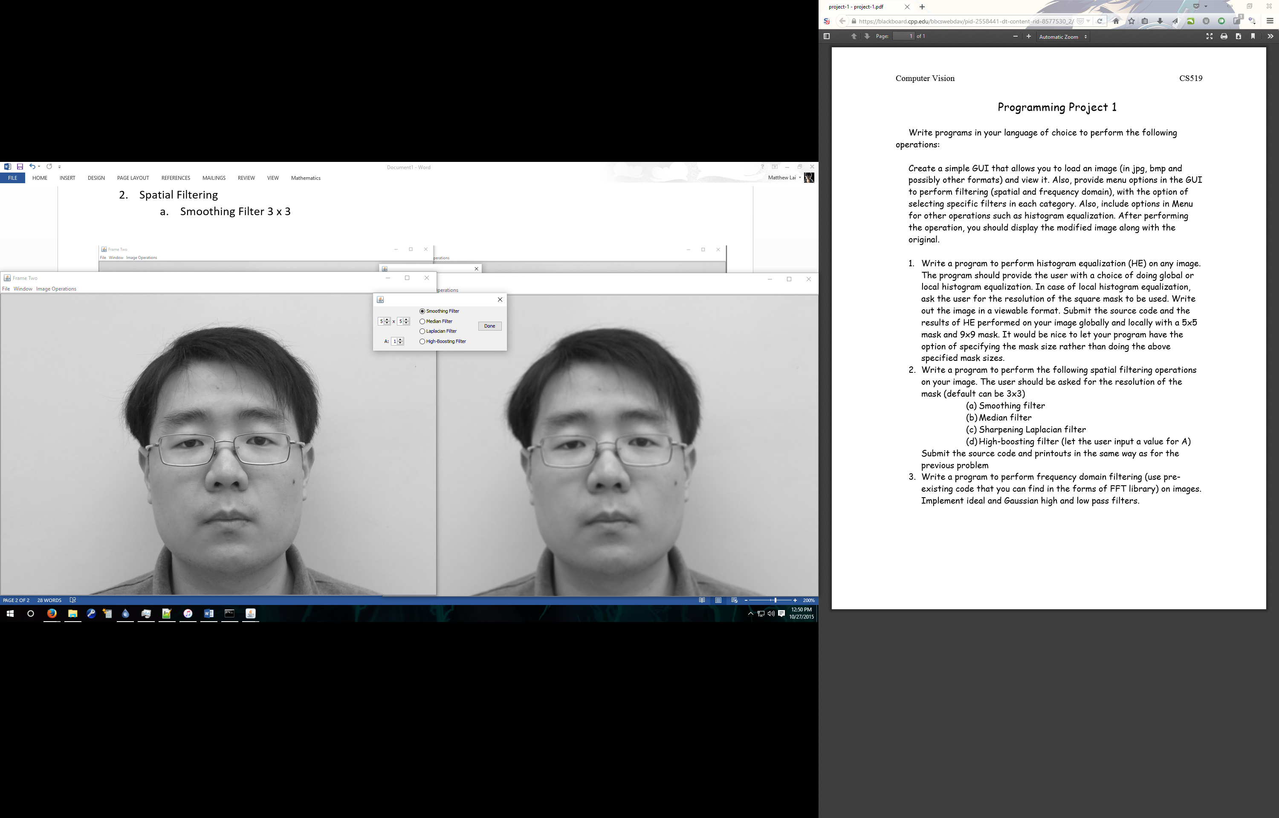

* 1. Median Filter 5 x 5

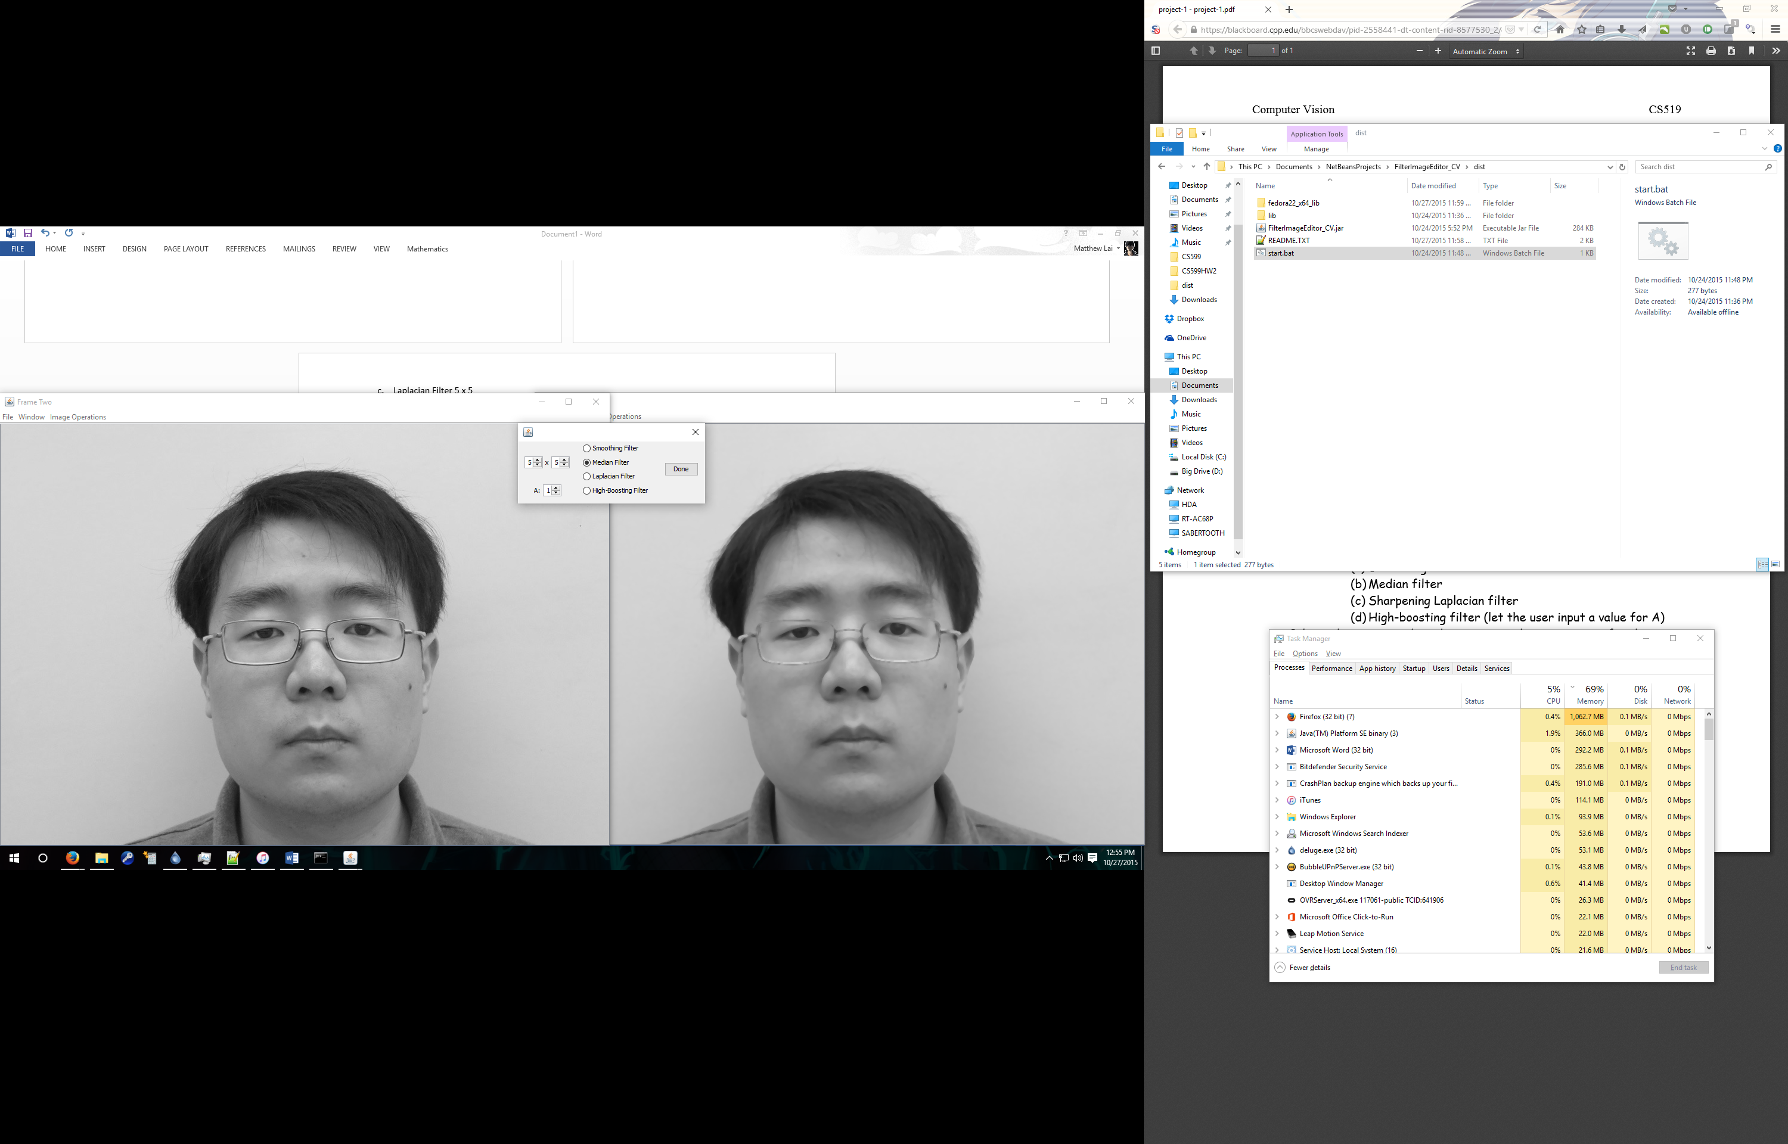

* 1. Laplacian Filter 5 x 5

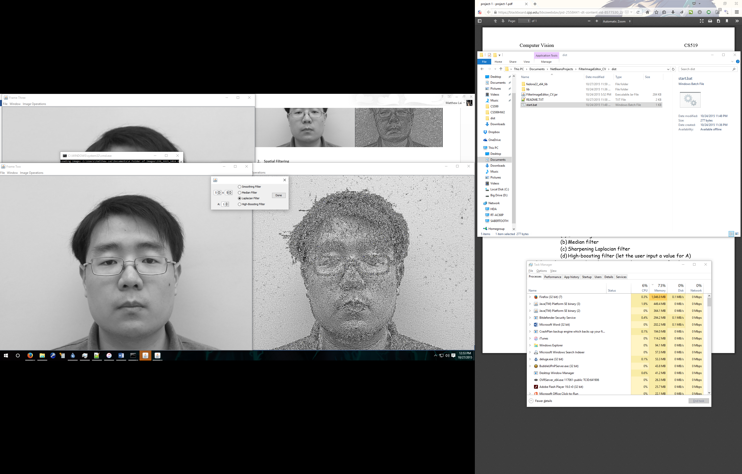

* 1. High-Boosting Filter 3 x 3 ; A = 0.5

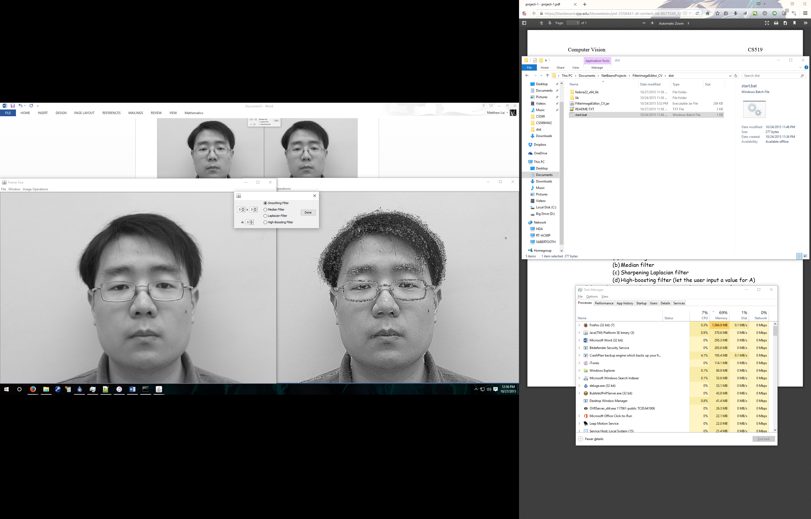

Source Code (Also Located in src/P1Filters/SpatialFilter.java):

// Performs the average smoothing with a uniform mask

private int[][] flatSmoothing(int[][] image, int xFilterSize, int yFilterSize)

{

// creates the mask

int [][] filter = new int[xFilterSize][yFilterSize];

int filterSum = 0;

for (int i = 0; i < filter.length; i++)

for (int j = 0; j < filter[i].length; j++)

{

filter[i][j] = 1;

filterSum += 1;

}

// correlates the mask with the image

int[][] returnImage = SpatialFilterUtil.correlation(image, filter);

for (int i = 0; i < returnImage.length; i++)

{

for (int j = 0; j < returnImage[i].length; j++)

{

returnImage[i][j] = returnImage[i][j]/filterSum;

}

}

// returns the correlated image

return returnImage;

}

private int[][] medianFilter(int[][] image, int xFilterSize, int yFilterSize)

{

// creates the output image

int [][] output = new int[image.length][image[0].length];

int dx = xFilterSize/2;

int dy = yFilterSize/2;

for (int x = 0; x < image.length; x++)

for (int y = 0; y < image[x].length; y++)

{

if (x - dx >= 0 && x + dx < image.length &&

y -dy >= 0 && y + dy < image[x].length)

{

// places neighborhood values into window

int c = 0;

int [] window = new int[xFilterSize*yFilterSize];

for (int i = -dx; i <= dx; i++)

for (int j = -dy; j <= dy; j++)

{

window[c] = image[x+i][y+j];

c++;

}

// Sorts Window and places median in the target pixel location

int[] sortedWindow = FilterUtilities.QuicksortMedian.sort(window);

output[x][y] = sortedWindow[sortedWindow.length/2];

}

else output[x][y] = image[x][y];

}

return output;

}

private int[][] laplacianFilter(int[][] image, int xFilterSize, int yFilterSize)

{

// calls the high-boost filter with A value of 1 and a negitivity value of 1

return highBoostFilter(image, xFilterSize, yFilterSize, 1, 1);

}

// highboost filter. Variable A modifies the algorithm, variable mod modifies the mask, either setting the

// center value to be positive or negative.

private int[][] highBoostFilter(int[][] image, int xFilterSize, int yFilterSize, double A, int mod)

{

// creates the filter mask

int [][] filter = new int[xFilterSize][yFilterSize];

int central = xFilterSize*yFilterSize - 1;

for (int i = 0; i < filter.length; i++)

for (int j = 0; j < filter[i].length; j++)

filter[i][j] = 1 * mod;

filter[xFilterSize/2][yFilterSize/2] = -central * mod;

// correlates the image with the mask

int[][] correlatedImage = SpatialFilterUtil.correlation(image, filter);

int[][] returnImage = new int[image.length][image[0].length];

// performs the high boost operations on the image.

for (int i = 0; i < returnImage.length; i++)

for (int j = 0; j < returnImage[i].length; j++)

returnImage[i][j] = (int)((double)image[i][j] * A) + (correlatedImage[i][j] * -1 * mod);

return returnImage;

}

1. Frequency Domain Filtering

Ideal High Pass

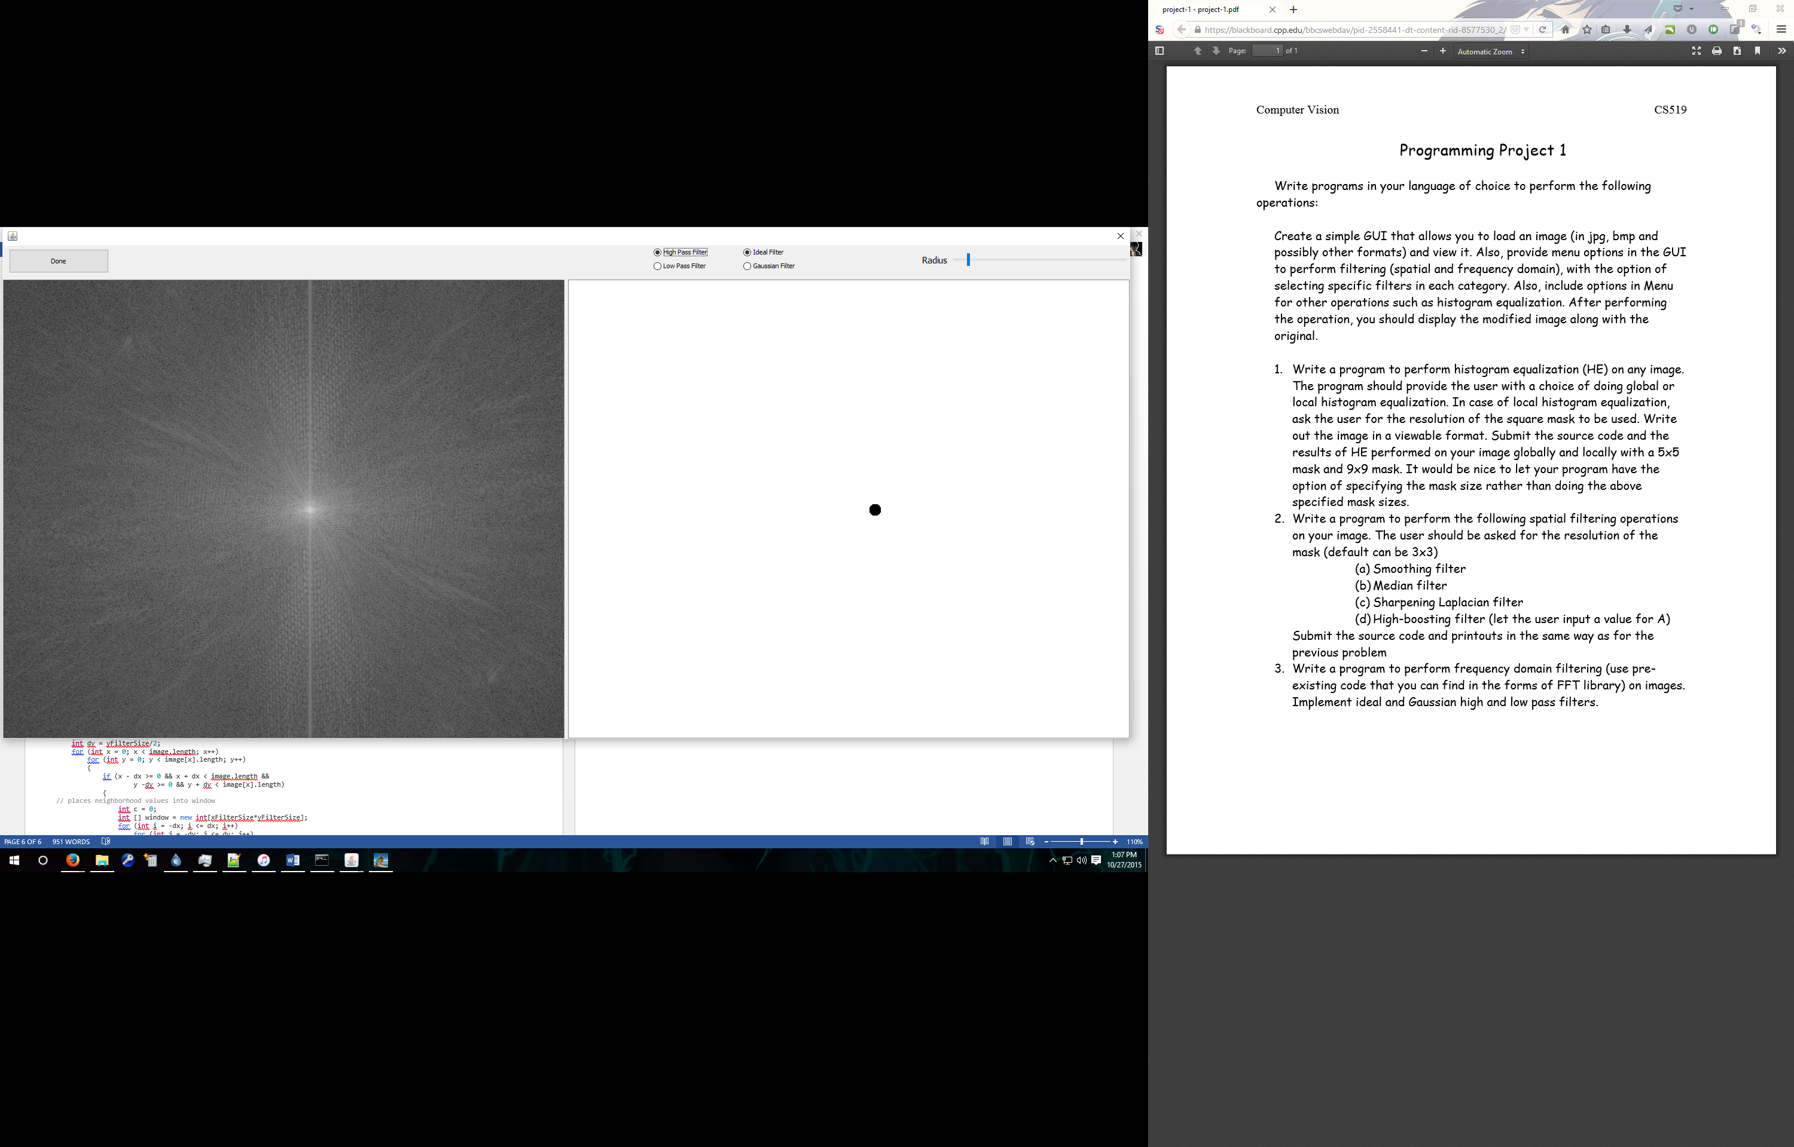

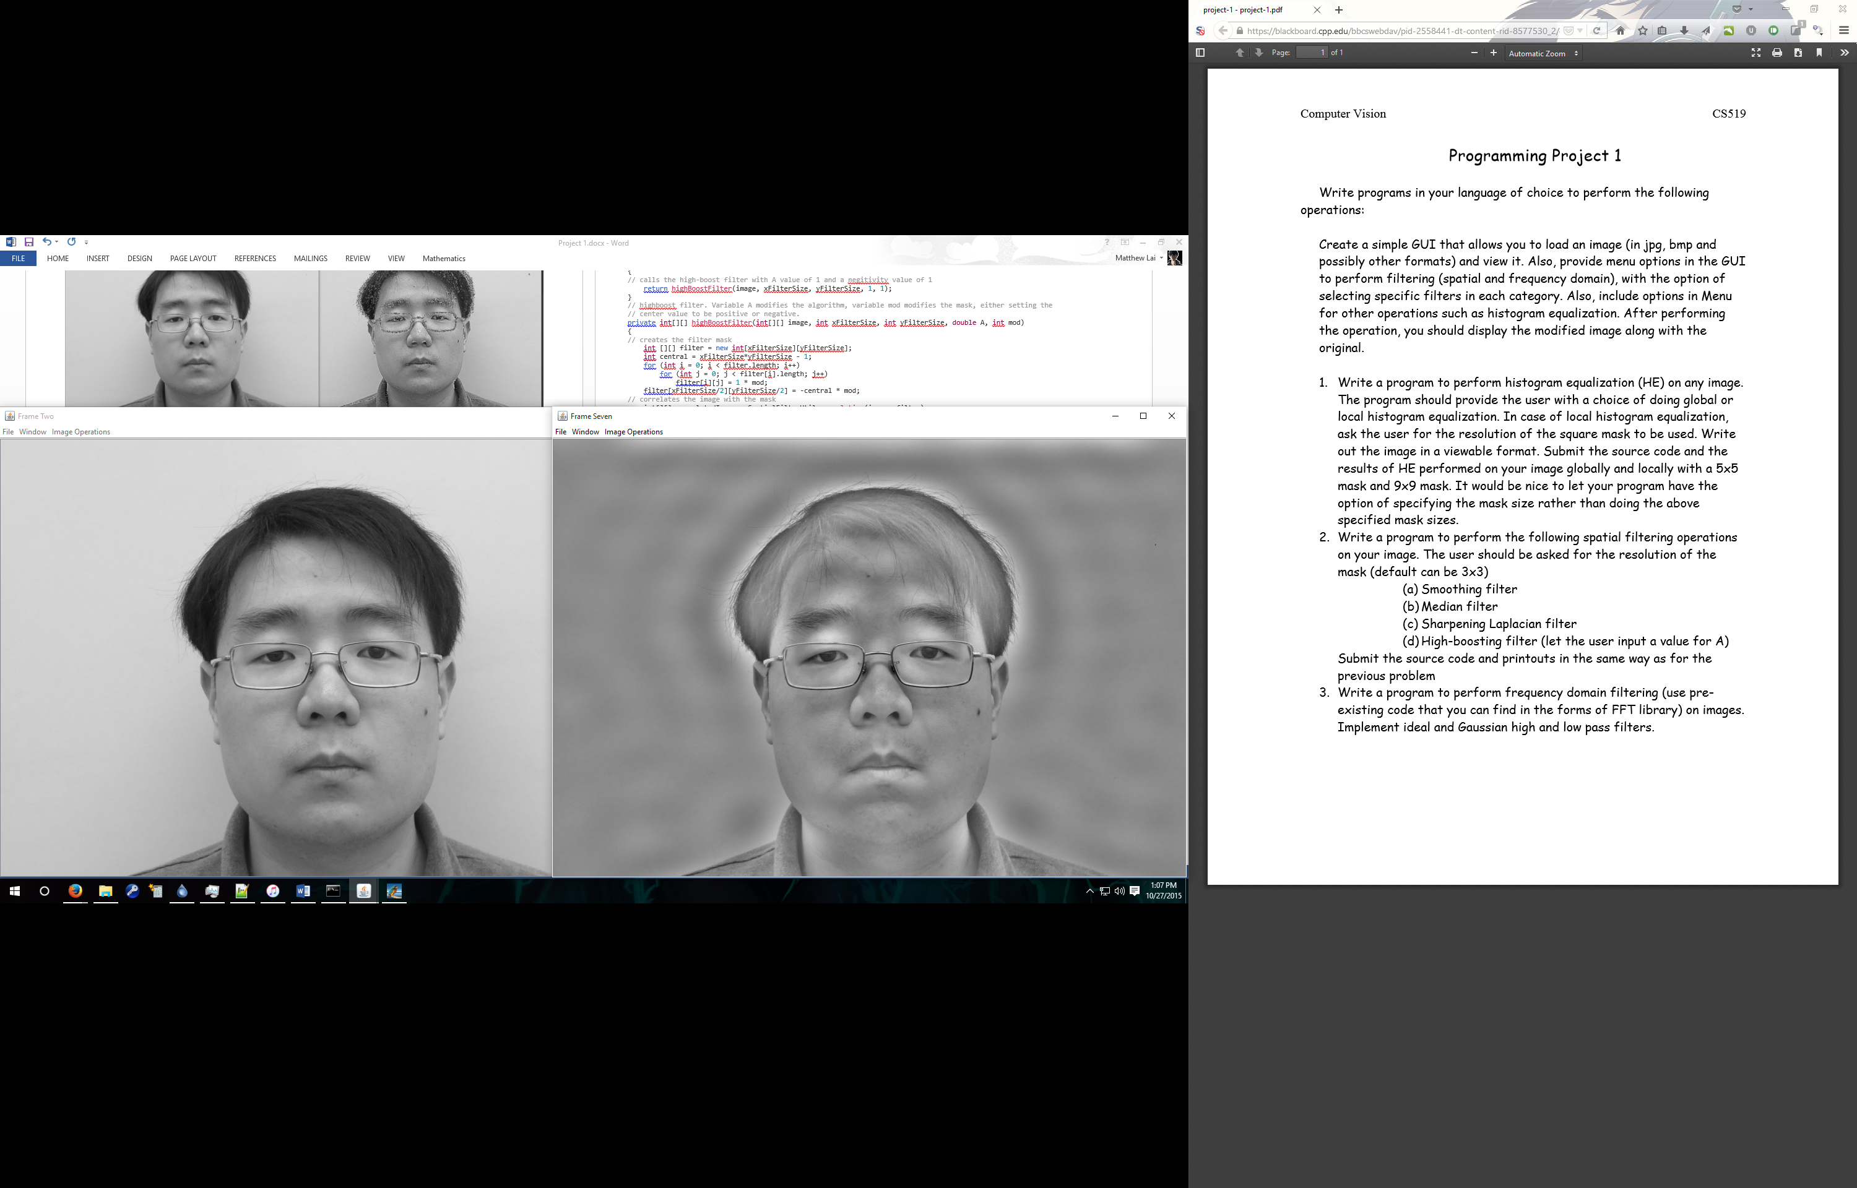

Ideal Low Pass

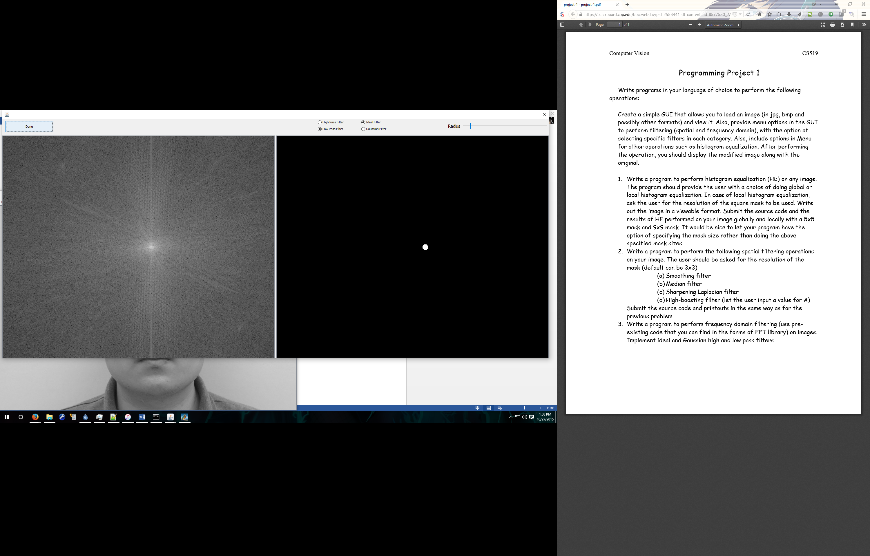

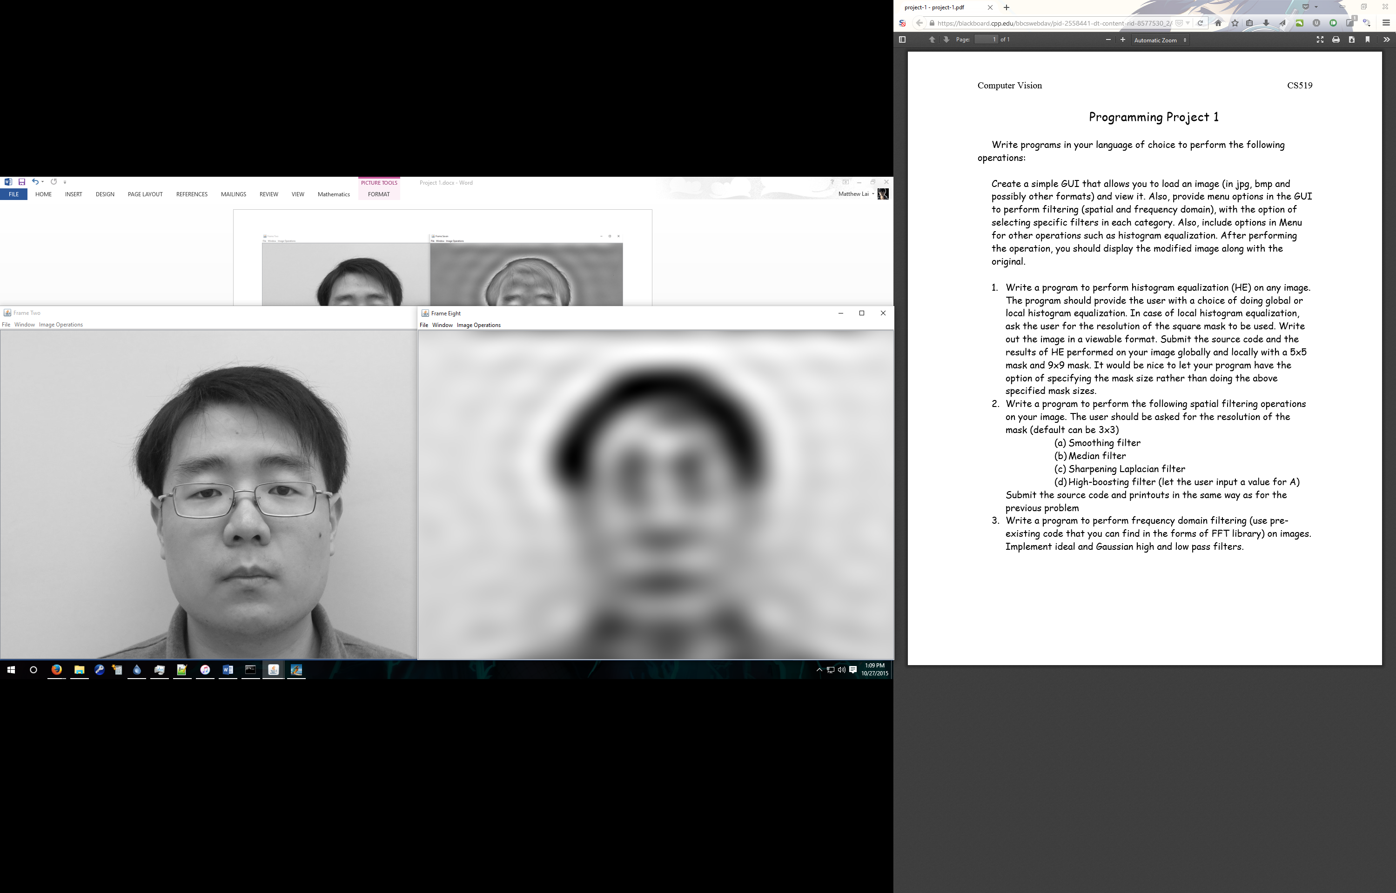

Gaussian High Pass

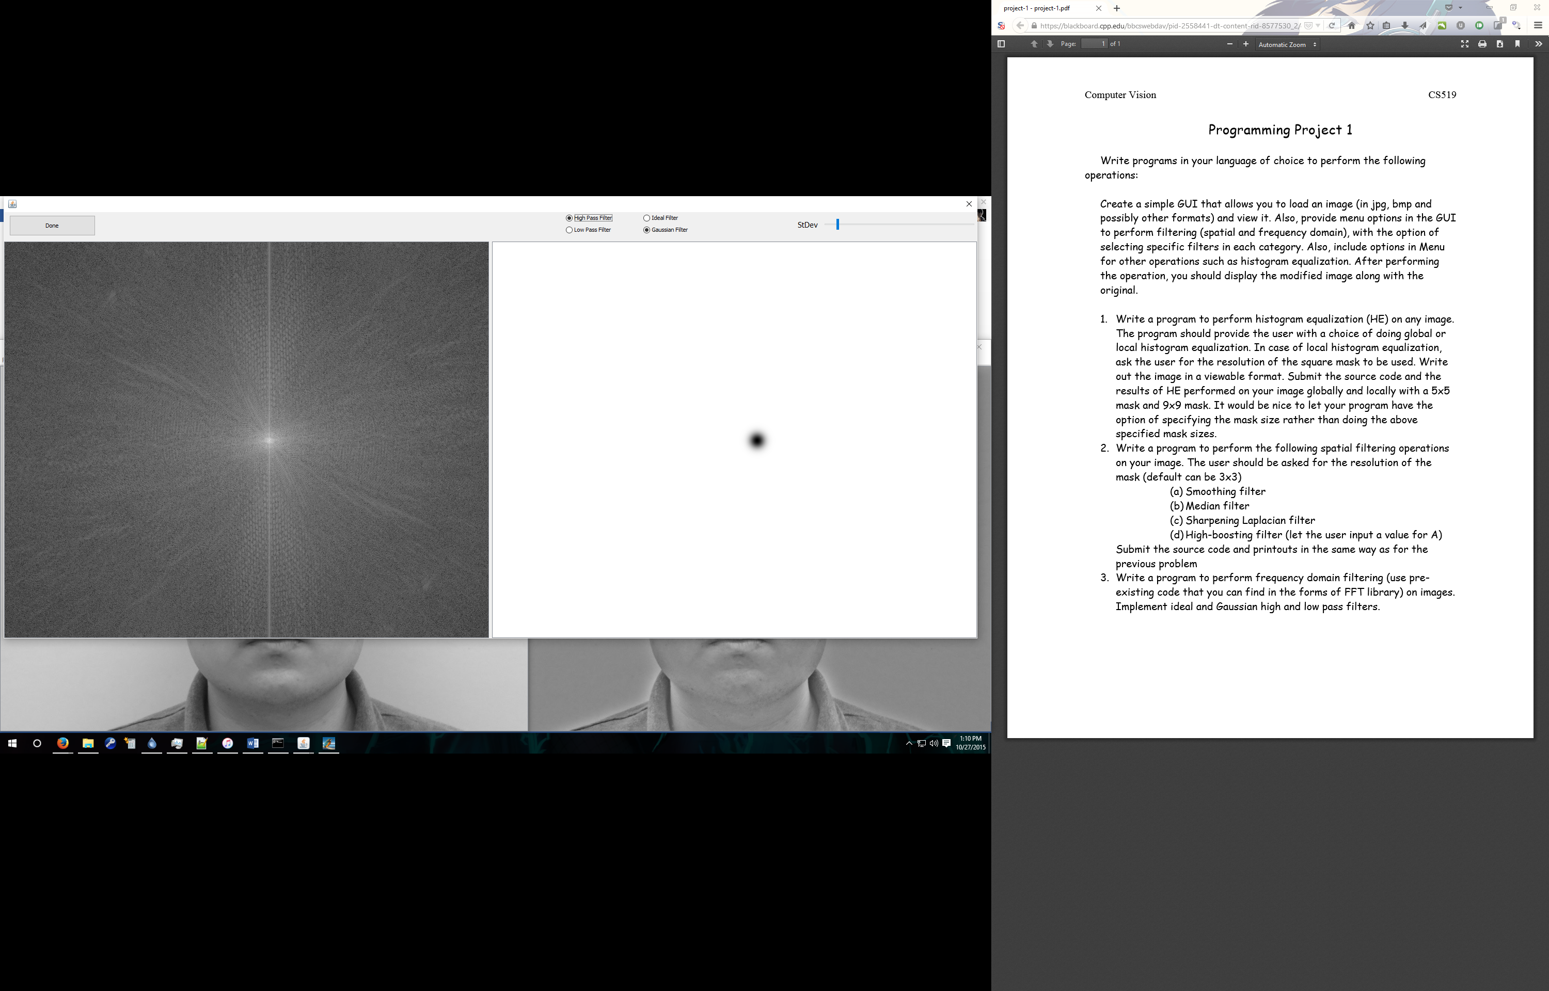

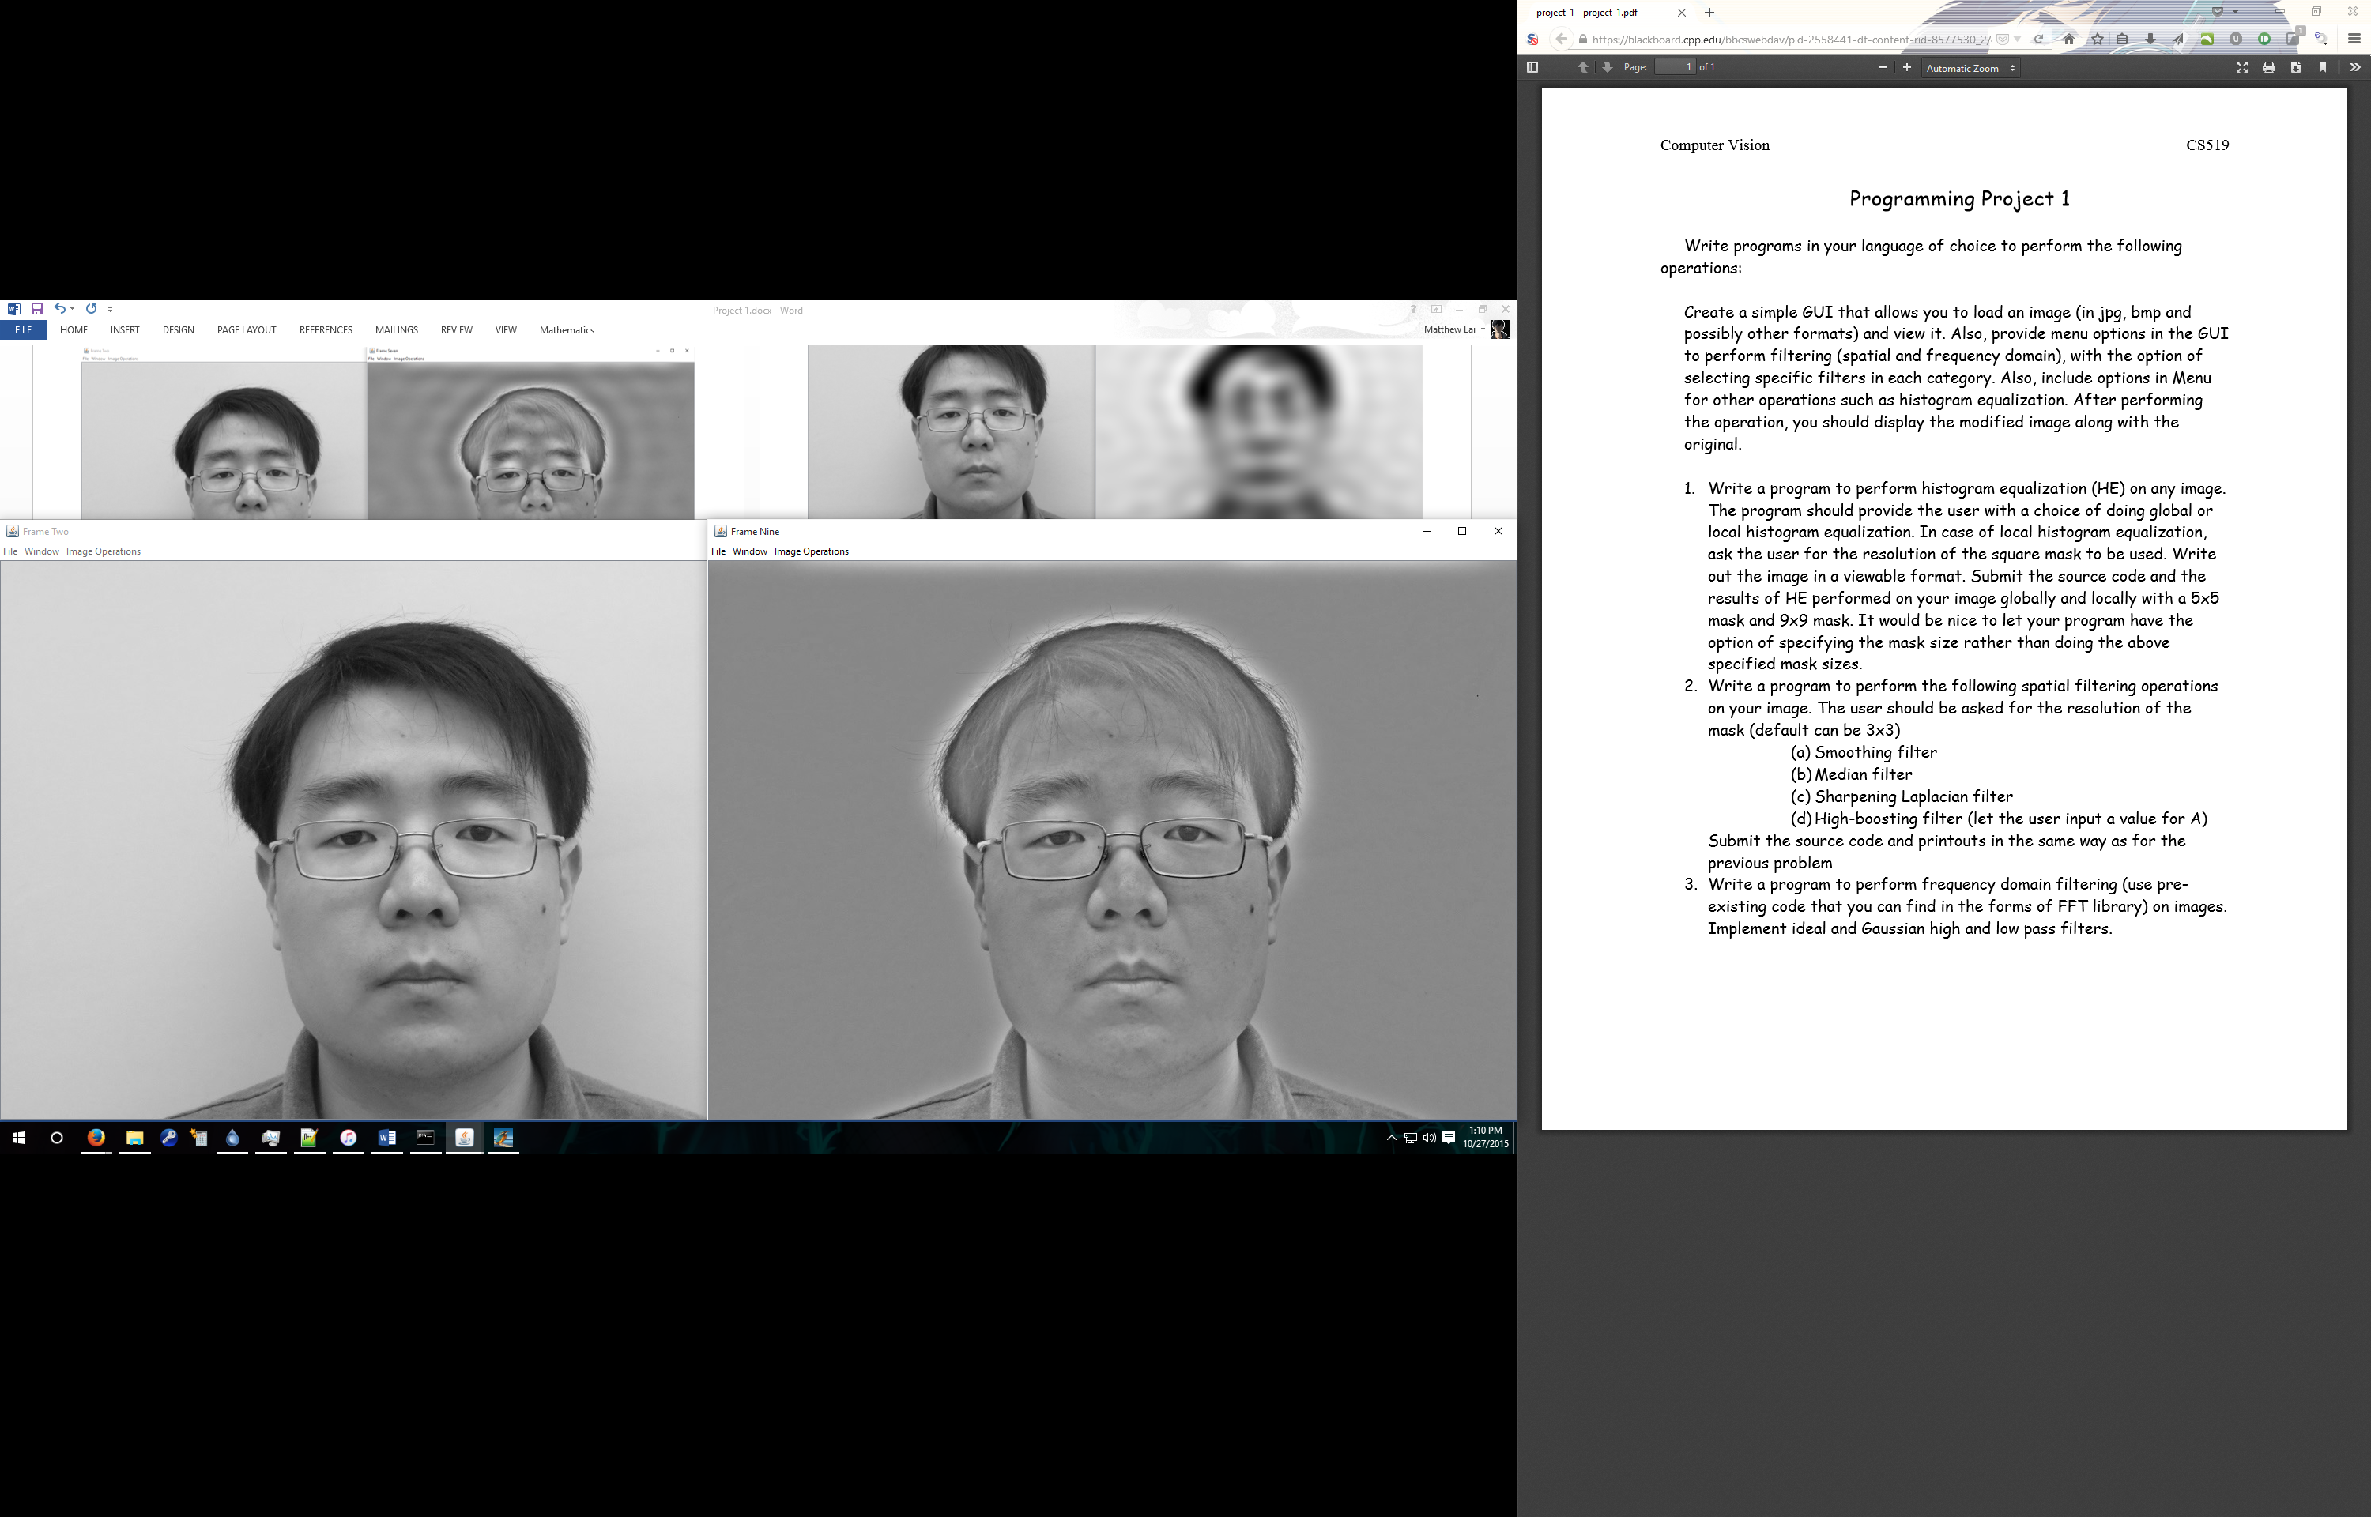

Gaussian Low Pass

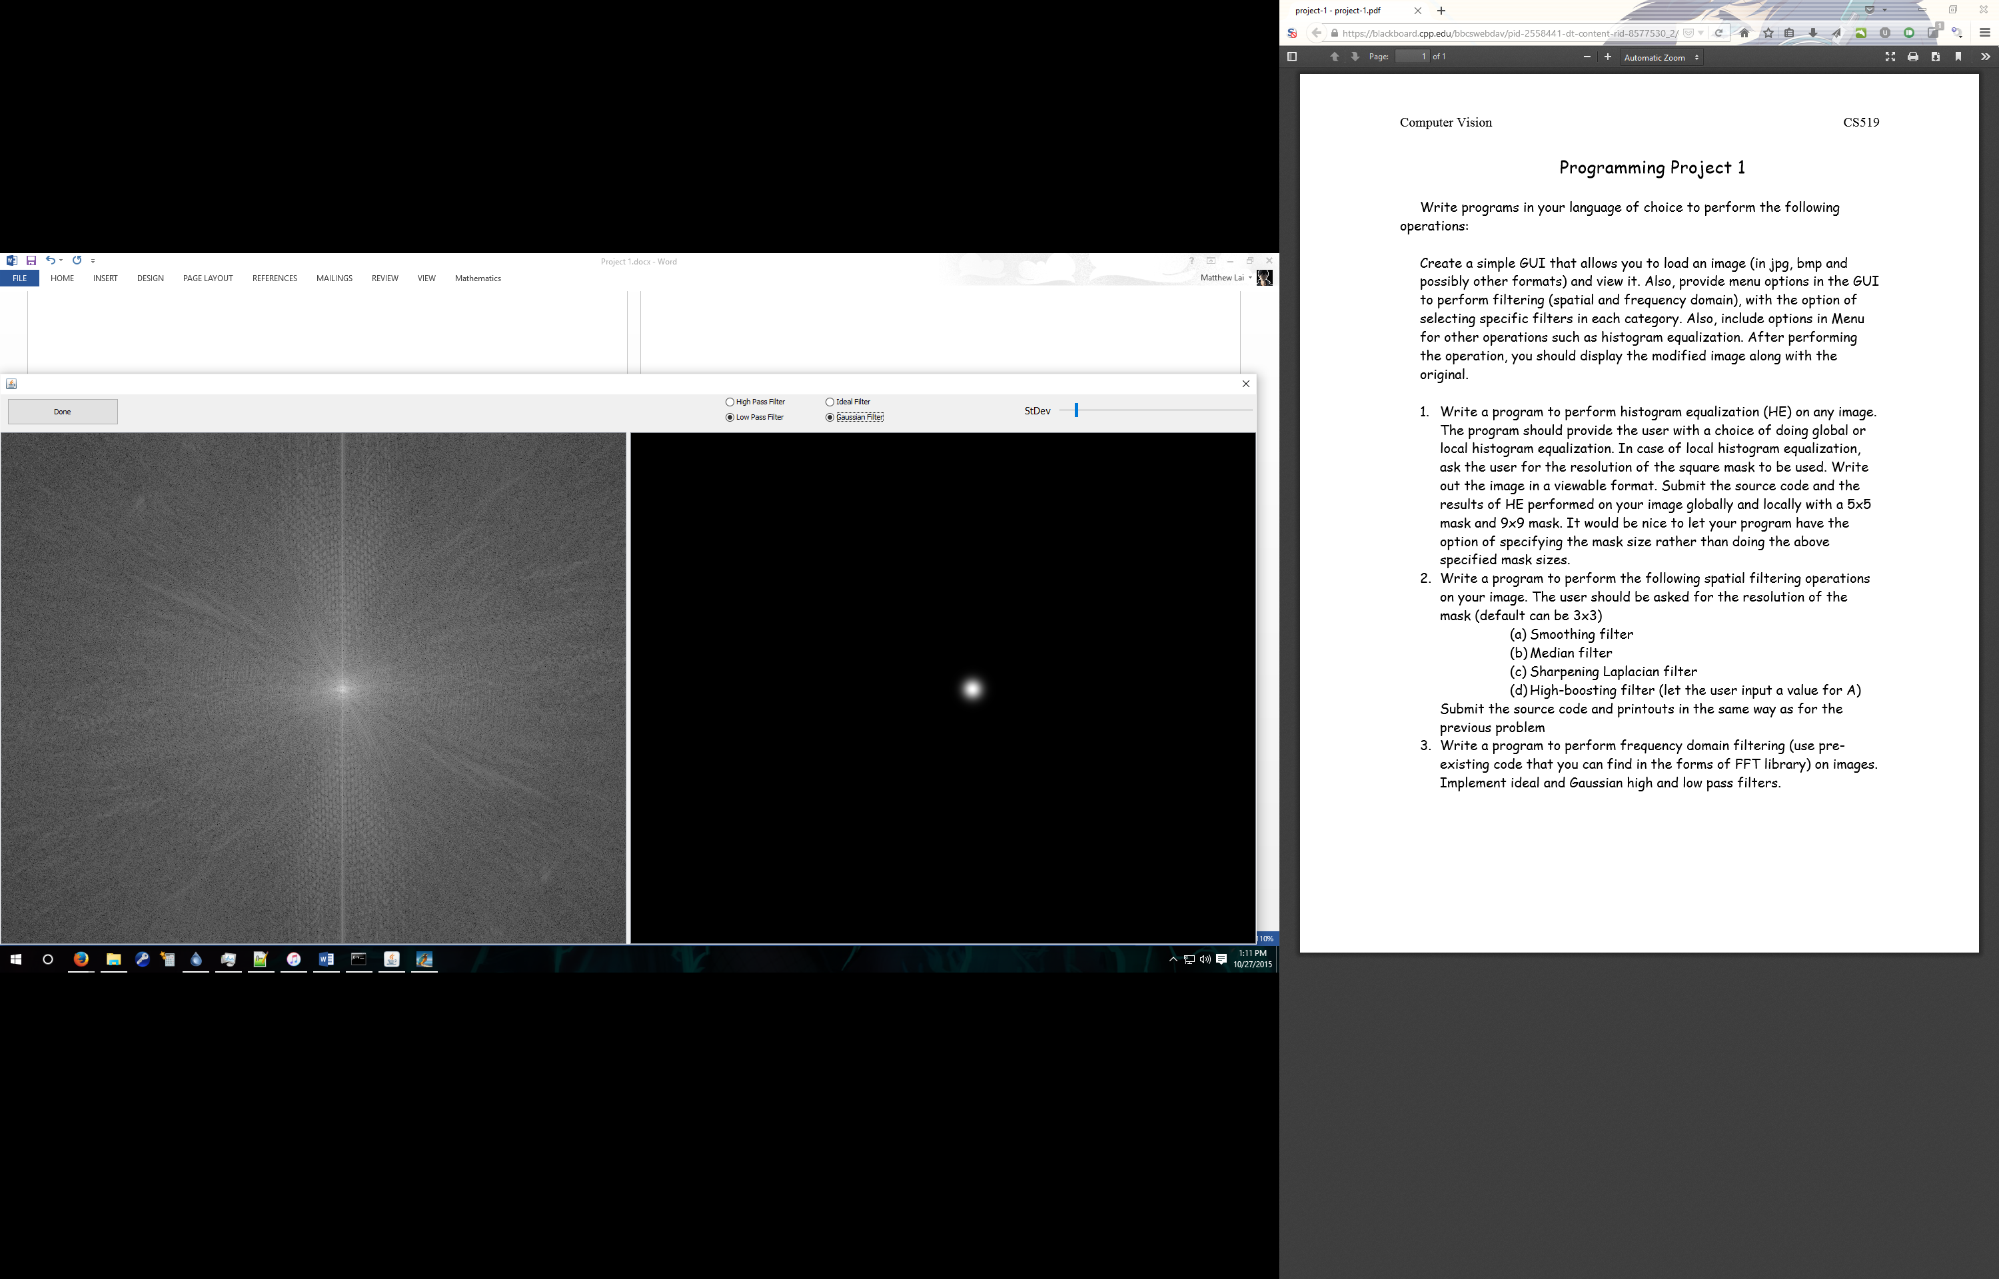

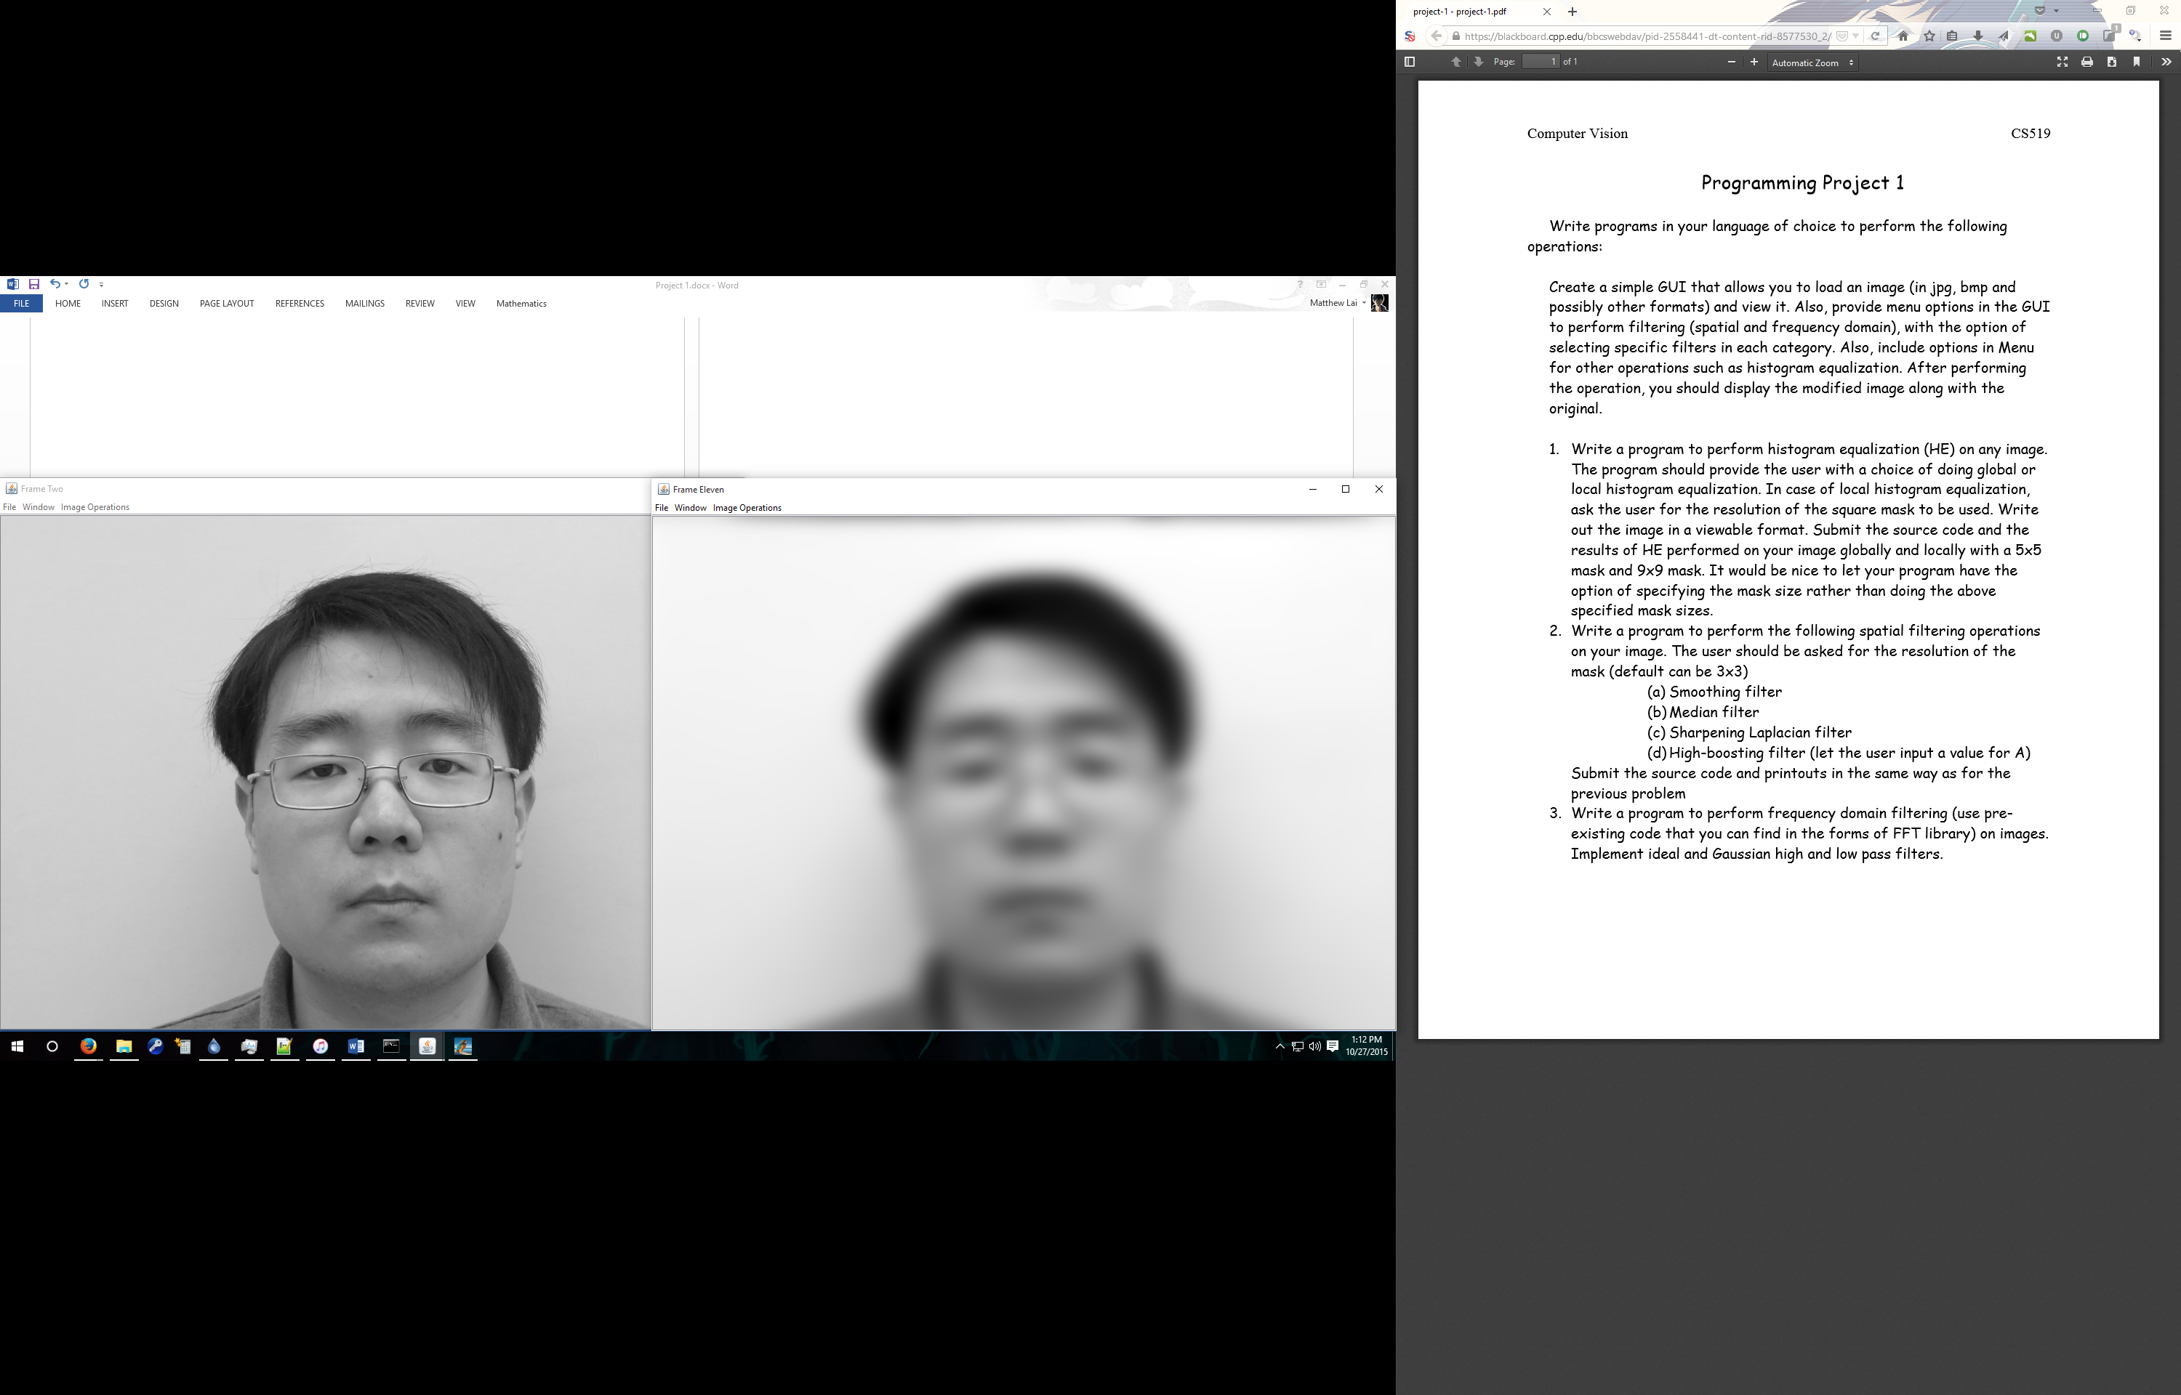

Source Code (Also Located in src/P1Filters/FourierPassFilters.java):

@Override

public RGBPixelArray filterImage(RGBPixelArray original)

{

// Convert RGBPixelArray to DFTObj fourier frequency transformed object

// consisting of Aplitude and Phase data as well as Matrix size and type

DFTObj tImage = OpenCV.dftForwardTransform(original.getGrayscaleValues());

// GUI to receive User input

FourierPassSlider fPS = new FourierPassSlider(tImage, this);

fPS.setVisible(true);

// Retrieve User Input transform filter from GUI

double[][] filter = fPS.getFilter();

// Shift DFTObj Amplitude Matrix Quadrants to allow for convolution with filter

tImage = OpenCV.shiftMagnitudeQuadrants(OpenCV.dftForwardTransform(original.getGrayscaleValues()), false);

// Convolve Filter (simple element by element multiplication

tImage = tImage.convolve(filter);

// Revert Quadrant Shift in Amplitude Matrix for reverse transformation back to spatial domain

tImage = OpenCV.shiftMagnitudeQuadrants(tImage, true);

// Return new RGBPixelArray containing inverse-transformed image

return new RGBPixelArray(OpenCV.dftInverseTransformToImage(tImage));

}

/**

* generateFilter, used by the FourierPassSlider GUI to generate the filters that is used

* by the GUI and that is used to filter the frequency image

*

* int width - The width of the filter

* int height - The height of the filter

* int hL - High/Low Filter Flag

* int iG - Ideal/Gaussian Filter Flag

* int mod - Radius/Standard Deviation of the Filter

*/

// hL : 0 - High, 1 - Low; iG : 0 - Ideal, 1 - Gaussian

public double[][] generateFilter(int width, int height, int hL, int iG, double mod)

{

// mod = 10; // default

double[][] filter = new double[height][width];

int cx = width/2;

int cy = height/2;

for (int y = 0; y < filter.length; y++)

{

for (int x = 0; x < filter[y].length; x++)

{

// Ideal

if (iG == 0)

{

if (dist(cx, cy, x, y) < mod)

{

filter[y][x] = 1;

if (hL == 0)

filter[y][x] = 0;

}

else

{

filter[y][x] = 0;

if (hL == 0)

filter[y][x] = 1;

}

}

// Guassian

if (iG == 1)

{

filter[y][x] = guassian(dist(cx, cy, x, y), mod);

// ideal

if (hL == 0)

filter[y][x] = 1 - filter[y][x];

}

}

}

return filter;

}

private static Mat shiftQuadrants(Mat matrix, boolean inverse)

{

Mat newMat = new Mat(matrix, Range.all());

int cx = (int)Math.ceil(newMat.cols()/2.0);

int cy = (int)Math.ceil(newMat.rows()/2.0);

if (inverse)

{

cx = (int)Math.floor(newMat.cols()/2);

cy = (int)Math.floor(newMat.rows()/2);

}

Mat q0 = new Mat(newMat, new Rect(0, 0, cx, cy));

Mat q1 = new Mat(newMat, new Rect(cx, 0, cx, cy));

Mat q2 = new Mat(newMat, new Rect(0, cy, cx, cy));

Mat q3 = new Mat(newMat, new Rect(cx, cy, cx, cy));

Mat tmp = new Mat(q0.size(), q0.type());

q0.copyTo(tmp);

q3.copyTo(q0);

tmp.copyTo(q3);

q1.copyTo(tmp);

q2.copyTo(q1);

tmp.copyTo(q2);

return newMat;

}

public static DFTObj shiftMagnitudeQuadrants(DFTObj obj, boolean inverse)

{

Mat matrix = obj.getMagnitude();

Mat newMat = new Mat(matrix, Range.all());

newMat = shiftQuadrants(newMat, inverse);

return new DFTObj(newMat, obj.getPhase(), obj.getOriginalSize(), obj.getOriginalType(), inverse);

}

public static DFTObj dftForwardTransform(int[][] image)

{

Mat matImage = new Mat(image.length, image[0].length, CvType.CV_32F);

for (int i = 0; i < image.length; i++)

for (int j = 0; j < image[i].length; j++)

matImage.put(i, j, image[i][j]);

return dftForwardTransform(matImage);

}

private static DFTObj dftForwardTransform(Mat originalMat)

{

java.util.List<Mat> planes = new java.util.ArrayList<>();

planes.add(new Mat(originalMat,Range.all()));

planes.add(Mat.zeros(originalMat.size(), CvType.CV_32F));

Mat newMat = new Mat(originalMat.size(), CvType.CV_32FC2);

Core.merge(planes, newMat);

Core.dft(newMat, newMat);

Core.split(newMat, planes);

Mat magI = new Mat(planes.get(0).size(), planes.get(0).type());

Mat phI = new Mat(planes.get(0).size(), planes.get(0).type());

Core.cartToPolar(planes.get(0), planes.get(1), magI, phI);

return new DFTObj(magI, phI, originalMat.size(), originalMat.type());

}

private static Mat dftInverseTransform(DFTObj obj)

{

if (!obj.isTransformable())

{

javax.swing.JOptionPane.showMessageDialog(null,"This DFTObject is not yet ready to be transformed. Please shift the quadrants.", "Error", javax.swing.JOptionPane.INFORMATION_MESSAGE);

return null;

}

Mat mergedMat = new Mat(obj.getOriginalSize(), obj.getOriginalType());

List<Mat> planes = new ArrayList<>();

planes.add(new Mat(mergedMat.size(), mergedMat.type()));

planes.add(new Mat(mergedMat.size(), mergedMat.type()));

Core.polarToCart(obj.getMagnitude(), obj.getPhase(), planes.get(0), planes.get(1));

Core.merge(planes, mergedMat);

Mat invDFT = new Mat(mergedMat.size(), mergedMat.type());

Core.idft(mergedMat, invDFT, Core.DFT_INVERSE + Core.DFT_SCALE, 0);

return invDFT;

}

Running the code:

It is possible to run the code simply by double clicking the FilterImageEditor_CV.jar file located in the ‘dist’ folder. However, the OpenCV library will not be linked to the code and the Fourier Pass Filter module will not work. All other filters will continue to function.

If you are running the program on Windows, simply run the start.bat file also located in the ‘dist’ folder. This will properly run the .jar file with the correct commands to link to the correct folders to allow the Fourier Filter module to work.

On any other operating system, you must first have compiled OpenCV 3.0.0 for your OS with the proper configurations to compile a Java OpenCV library:

1. The following website has instructions on how to compile the OpenCV software to include Java bindings. It is nearly the same as compiling it regularly since Java support is built in:

<http://docs.opencv.org/doc/tutorials/introduction/desktop_java/java_dev_intro.html>

Simply make sure to have Java, CMake, and Apache Ant installed, then run the commands as instructed from the above website, ensuring that the build process lists java as one of the modules that will be built.

1. Copy the ./opencv-3.0.0/build/bin/opencv-300.jar file, generated during the build and make process, to the dist/lib/ folder of my project, replacing the .jar file that is already there.
2. Run the following command from the terminal, replacing the path in the command with the path of the folder containing the Java OpenCV library file "libopencv_java300.so". This file is normally located in "./opencv‑3.0.0/build/lib/":

java -Djava.library.path=/path/to/lib/ -jar dist/FilterImageEditor_CV.jar